Home Work 4

1.

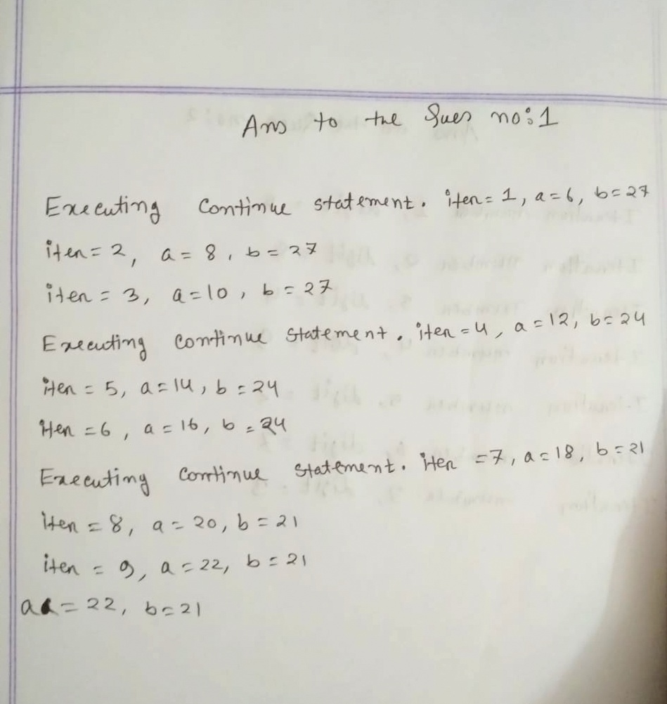

2.

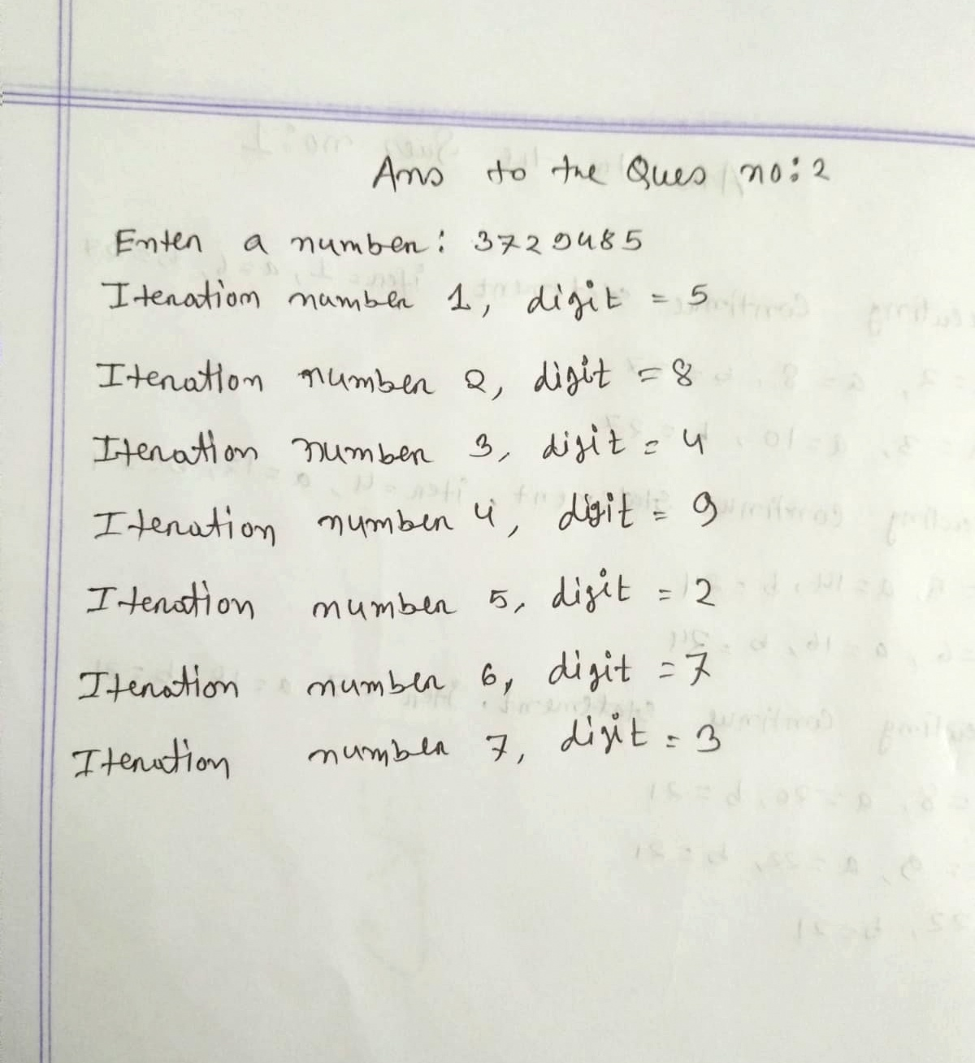

3.

#include <math.h>

#include <stdio.h>

double Series(int n)

{

int i;

double sums = 0.0, ser;

for (i = 1; i <= n; ++i) {

ser = 1 / pow(i, i);

sums += ser;

}

return sums;

}

int main()

{

int n;

printf("ENTER THE VALUE OF n : ");

scanf("%d",&n);

double res = Series(n);

printf("SUM OF THE SERIES IS: %.3f", res);

return 0;

}

Output:

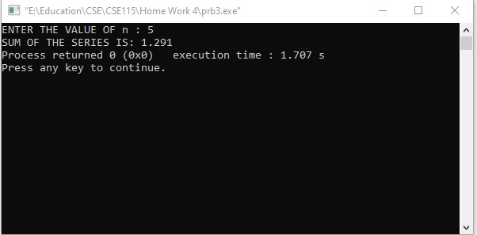

4.

#include <stdio.h>

int main()

{

int n,i,sum=0;

printf("Enter n value: ");

scanf("%d",&n);

for (i=1;i<=n;i++)

sum=sum+i;

printf("The sum of first %d is %d",n,sum);

return 0;

}

Output:

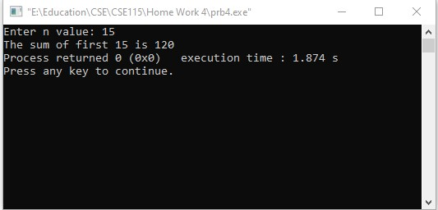

5.

#include <stdio.h>

#include <conio.h>

int main(){

int N, facto, count;

printf("Enter a number for find the factorial :");

scanf("%d",&N);

for(count = 1, facto = 1; count <= N; count++){

facto = facto \* count;

}

printf("Factorial of %d is : %d", N, facto);

return 0;

}

Output:

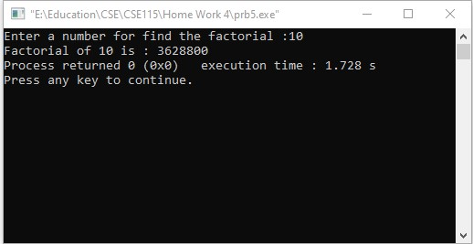

6.  
#include <stdio.h>

int main() {

int base, power;

double result = 1.0;

printf("Enter a base number: ");

scanf("%d", &base);

printf("Enter the power, the number to be raised: ");

scanf("%d", &power);

while (power != 0) {

result \*= base;

--power;

}

printf("Answer = %.0lf", result);

return 0;

}

Output:

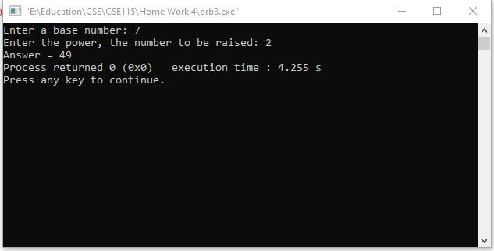

7.

#include <stdio.h>

int main()

{

int n1, n2;

printf("Enter n1: ");

scanf("%d",&n1);

printf("Enter n2: ");

scanf("%d",&n2);

int temp;

if(n1>n2)

{

temp=n2;

n2=n1;

n1=temp;

}

int i=0;

int count=0;

for(i=n1+1;i<n2;i++)

{

if(i%3==0&&i%5!=0)

{

count++;

}

}

printf("%d numbers",count);

}

Output:

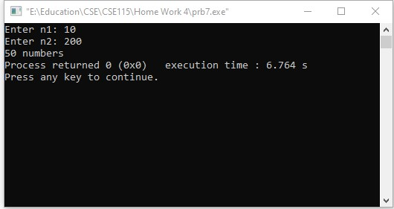

8.

a)

#include<stdio.h>  
int main()  
{  
   int i,j,n;  
   printf("Enter number of rows: ");  
   scanf("%d",&n);  
   if(n%2!=0)  
   {  
       for(i=n;i>=1;i--)             
       {  
           for(j=1;j<=i;j++)         
           {  
               printf("\* ");  
           }  
           printf("\n");                   
       }  
   }  
   else  
       printf("Enter a odd number");  
   return 0;  
}Output:

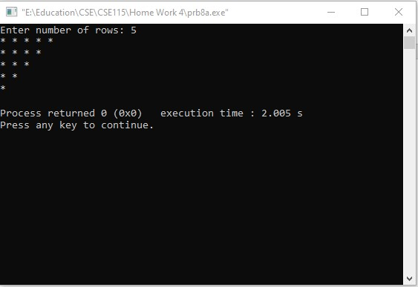

b)

#include<stdio.h>

#include<conio.h>

int main()

{

int n, s, i, j;

printf("Enter number of rows: ");

scanf("%d",&n);

for(i = 1; i <= n; i++)

{

for(s = i; s < n; s++)

printf(" ");

for(j = 1; j <= i; j++)

printf("\* ");

printf("\n");

}

return 0;

}

Output:

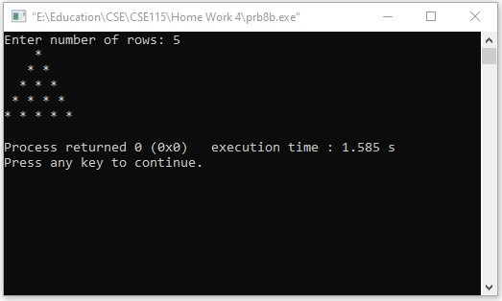

c)

#include<stdio.h>

#include<conio.h>

int main()

{

int n, s, i, j;

printf("Enter number of rows: ");

scanf("%d",&n);

for(i = n; i >= 1; i--)

{

for(s = i; s < n; s++)

printf(" ");

for(j = 1; j <= i; j++)

printf("\* ");

printf("\n");

}

return 0;

}

Output:

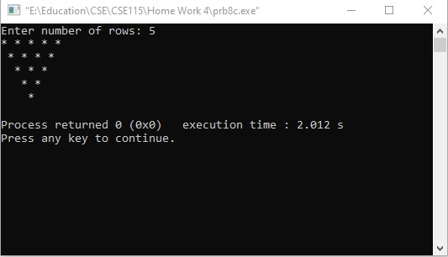

d)

#include<stdio.h>

#include<conio.h>

int main()

{

printf("Enter size of rows: ");

int n, i, j, m = 1, p;

scanf("%d",&n);

for(i = 0; i <= n; i++)

{

for(j = n; j > i; j--)

{

printf(" ");

}

printf("\*");

if (i > 0)

{

for(p = 1; p <= m; p++)

{

printf(" ");

}

m += 2;

printf("\*");

}

printf("\n");

}

m -= 4;

for(i = 0; i <= n-1; i++)

{

for(j = 0; j <= i; j++)

{

printf(" ");

}

printf("\*");

for(p = 1; p <= m; p++)

{

printf(" ");

}

m -= 2;

if(i != n-1)

{

printf ("\*");

}

printf("\n");

}

return 0;

}

Output:

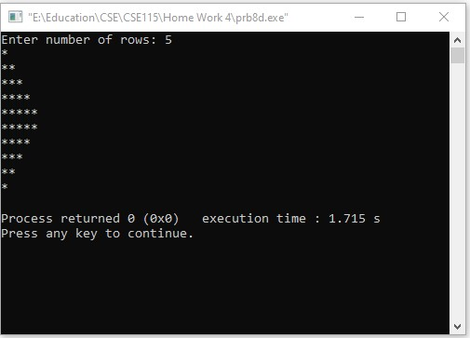

e)

#include<stdio.h>

int main()

{

int i,j,n,k;

printf("Enter size of Diamond: ");

scanf("%d",&n);

if(n%2!=0)

{

for(i=1;i<=n;i++)

{

for(k=i;k<=n;k++)

printf(" ");

for(j=1;j<=(2\*i-1);j++)

{

if(j==1||j==2\*i-1)

printf("\*");

else

printf(" ");

}

printf("\n");

}

for(i=n-1;i>=1;i--)

{

for(k=n;k>=i;k--)

printf(" ");

for(j=1;j<=(2\*i-1);j++)

{

if(j==1||j==2\*i-1)

printf("\*");

else

printf(" ");

}

printf("\n");

}

}

else

printf("Enter a odd number");

}

Output:

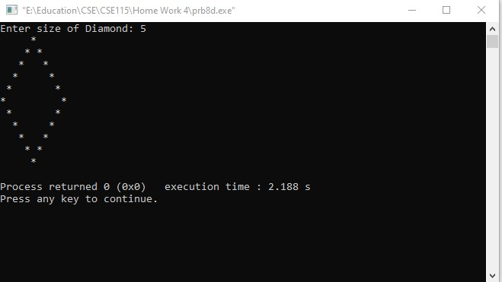

f)

#include<stdio.h>

int main()

{

int i,j,n,k;

printf("Enter value of n : ");

scanf("%d",&n);

if(n%2!=0)

{

for(i=1;i<=n;i++)

{

for(k=1;k<=n-i+1;k++)

printf("\*");

for(j=1;j<2\*i-1;j++)

printf(" ");

for(k=1;k<=n-i+1;k++)

printf("\*");

printf("\n");

}

for(i=2;i<=n;i++)

{

for(k=1;k<=i;k++)

printf("\*");

for(j=1;j<2\*(n-i)+1;j++)

printf(" ");

for(k=1;k<=i;k++)

printf("\*");

printf("\n");

}

}

else

printf("Enter a odd number");

}Output:

